REALITIES
Each of our lives is a narrative that too often is at the hands of others (teachers included, obviously) for editing. Such was the case for Joanne Lee and her teenage son, Skylar, a transgender boy who took his own life. He left a note saying that transitioning from female to male was not a factor in his death, but Skylar also wrote “It is not justice if we leave behind members of our communities, if we ignore the interconnected oppression of those we share community with.”
Joanne remembers a loving child, a passionate artistic boy who loved to draw and who supported fellow classmates when they needed him. She remembers her son petitioning his high school to elect a gender-neutral homecoming court instead of sticking to the strict terms of Homecoming King and Queen. She remembers him committed to racial justice and to fundamental rights for all students at his high school.
But the journals he kept also revealed a very vulnerable child who often felt invisible and invalidated as he faced discrimination and rejection from a society that did not want to support him and from his school that made his daily life a challenge. Joanne also remembers that, as the most important adult in his life, she never talked to him about being transgender. She tried to learn what it meant to be transgender, but her progress was too slow. His vulnerability, his anxiety, and his depression were becoming the edits in his life that made him take his life.

Skylar’s story is just one tragic example of the consequences when we, the adults in an LGBTQ student’s life, don’t love and support them for who they are. Shouldn’t our edits in their stories remind them they were born just as joyful and happy as we were and deserve the fundamental right to stay that way?
- 29% of transgender youth have been threatened or injured on school property with a weapon.
- 43% of these same youth have been bullied at school.
- 29% of have attempted suicide.
- 16% of gay, lesbian, and bisexual youth have been threatened or injured on school property with a weapon.
- 29% of these same youth have been bullied at school
- 22% have attempted suicide.
In comparison only 7% of cisgender students have been threatened with weapons and only 7% of these youth have attempted suicide.
Even though these numbers were posted in 2020 by the CDC in its National Youth Risk Behavior Surveillance Results, they are probably an undercount. None of this also is probably startling information to you as an educator. LGBTQ youth continue to suffer higher health and suicide risks than their peers and that trend really hasn’t changed over time. What is sad is that in many areas of the data the LGBTQ student community is facing more disparities than they were in 2017 when the data was last collected.
And did you know that in Ohio LGBTQ students
- Heard school staff make homophobic remarks (15%) and negative remarks about someone’s gender expression (33%);
- Never reported harassment incidents to staff (57%);
- Were disciplined more for public displays of affection than non-LGBTQ students (35%);
- Were unable to use the school bathroom aligned with their gender (47%);
- Were prevented from using their chosen name or pronouns in school (LGBTQ-24% and transgender students-47%); and
- Dealt with other issues such as being discouraged from playing school sports because of their identity, being unable to bring a same-gender date to a school dance, being discouraged or prevented from wearing clothes deemed “inappropriate” based on gender, and being disciplined at school for identifying as LGBTQ. (Findings from the GLSEN report on School Climate for LGBTQ Students in Ohio, 2019)
Are you aware of the microaggressions used daily against LGBTQ students? You know, those intentional or unintentional terms that communicate hostile, derogatory or negative attitudes based on stigmas.
- You’re gay? I would never have guessed.
- That’s go gay. That’s so queer.
- How did you turn gay?
- Which one of you is the “guy?”
- I’m not homophobic, but…
- Why do you have to flaunt it?
- You can do what you want, but I don’t have to approve of it.
- You’re being oversensitive.
- Aren’t you making life hard for yourself?
- He’s gay and I don’t want him to hit on me.

So… what is a realistic scenario daily for LGBTQ students entering the school from the bus off-loading area? Of course, some of that reality is dependent on grade level—elementary, middle school, or high school—but as cisgender students run pass these students they may hear, “Move it, Fag.” Going to their lockers, they may be laughed at as a straight student aggressively shoves them into lockers as a teacher walks by. Their Gay-Straight Alliance (GSA) posters are marked up or torn down when other club posters aren’t, and their health teachers can’t (or won’t) answer their questions about safer sex, knowing the students are gay.
As a vulnerable population, they lack teacher role models and other supportive teachers who may isolate, exclude or marginalize (knowingly or unknowingly). Acanthus R., a 17-year-old pansexual, non-binary transgender student, says it is “like a little mental pinch” when teachers use the wrong pronouns. “It doesn’t seem like a big deal, but eventually you bruise.” (Human Rights Watch, Discrimination Against LGBT Youth in US Schools)

PRESSURES
The pressures described for these marginalized students not only engender lower self-esteem, loss of family and friends, higher levels of depression, substance abuse, self-destructive behaviors, privacy guarantees and homelessness but also increased absenteeism, limited educational and extracurricular opportunities, lower academic achievement, and they were less likely to pursue any post-secondary education.
LGBTQ kids were asked to identify the most important problem facing their lives right now.
- 26% said non-accepting families
- 21% said school/bullying problems
- 18% said fear of being outed
Non-LGBTQ kids were asked to identify the most important problem facing their lives right now.
- 25% said classes/exams/grades
- 14% college/career
- 11% financial pressures related to college or job
The pressures on teachers and school districts to educate the “whole child”—all of them at all grade levels—also can engender certain school problems that are ignored or not easily solved in today’s highly contentious and polarized world. After all, each person has their own narrative they like to impose on others, despite the realities you, as educators, experience in the trenches. When in those trenches, staff members often face the following realities on a daily basis with uncertain results if not grounded in best practices.

- Confronting and preventing student bullying and harassment in bathrooms, on buses, in locker rooms and hallways. Most behaviors are not openly done in front of school personnel
- Addressing effectively and sensitively LGBTQ topics in the classroom when they arise
- Excluding discussion of LGBTQ topics at all, erring on the side of caution to prevent backlash from parents or administrators
- Hearing slurs (That’s so gay!) in the classroom and doing little to intervene or call it out
- Being dismissive or tacitly agreeing with derogatory comments
- Lacking teacher training to know when and how to intervene when slurs are used
- Identifying and addressing one’s own biases
- Neglecting or ignoring LGBTQ perspectives or skimming over them
- Knowing little about gender pronoun use and other LGBTQ rights
- Getting caught between parenting requests and LGBTQ student privacy rights and requests (Names used in class, on transcripts and diplomas, for example)
- Defaulting to what is easiest and safest, being unsure of what school policy and state laws do and do not prohibit

BEST PRACTICES IN THE SCHOOLS
We’re going to examine the settled law in a minute that supports your efforts to do what is best for students in the here and now. But the key word is “support” both for you and for students. So where should we begin? First of all…
- Make sure your policies reflect your priorities
- Develop a district-wide Diversity, Equity and Inclusion (DEI) policy and educate staffs as to its content. Presently, only about five districts in Ohio have a DEI policy, Worthington being one of them so congrats. Many other districts are still in the talking stage. The policy should address issues of inclusiveness in education alone.
- Lays out clear expectations about student rights and responsibilities of upholding those rights.
- Educate staff on the policies
- Review the legal rights of LGBTQ students
- Have honest staff discussions about the school pressures we just went over that teachers and schools face
- Reject the premise that “out-of-sight” means “out-of-mind” concerning LGBTQ students. A Bexley student stated her school district wasn’t outright discriminatory in addressing LGBTQ issues, just indifferent
- Have the tough discussions with LGBTQ students as to what is really happening in the hallways, locker rooms, and classrooms- Genuinely listen- This isn’t a one-and-done activity
- Don’t let the advisor to a Gay-Straight Alliance be the only one listening
- Coordinate discussions with other student groups such as student council
- Act on what needs to be done about bullying, harassment, microaggressions, dress codes, sex education, school-wide messaging, safe spaces
- Encourage teachers to be good allies
- Speak up against biased remarks every time, without exception (Interrupt)
- Ask simple questions to learn why the comment was made and how it can be addressed (Question)
- Explain why a word or phrase is hurtful and help students differentiate between impact and intent (Educate)
- Change the culture by all teachers interrupting, questioning, and educating (Echo)
- Develop an inclusive classroom culture
- Model inclusive pronoun usage
- Facilitate conversations about identity, challenge gender norms
- Find opportunities for LGBTQ inclusion in lesson plans. Teachable moments can act both as a window and a mirror for all students
- Learn continuously about what can and should be done to foster inclusivity

LQBTQ YOUTH WHO HAVE AT LEAST ONE ACCEPTING ADULT ARE 40% LESS LIKELY TO ATTEMPT SUICIDE (TREVOR PROJECT NATIONAL SURVEY, 2019)

TEACHERS PROVIDE A SAFE SPACE AND REFUGE FOR THESE KIDS WHO MAY COME FROM HOMES THAT ARE UNSPPORTIVE OR EVEN DANEROUS

TEACHERS CHANGE LIVES

TEACHERS SAVE LIVES WHEN THEY STEP UP FOR LGBTQ KIDS THE SAME WAY THEY DO FOR ALL KIDS

- Establish allies in the community
- Build relationships with local business leaders, sports teams, churches, or other organizations that are influential and supportive of inclusivity and who can help you educate
- Do not let misinformation go unchecked
  - Schools should not be promoting a gay agenda
  - LGBTQ students are getting special treatment
  - Sex shouldn’t be an issue in the classroom
  - Students are too young to know their gender identity
  - Transgender identity is a mental illness
- Know the landscape of hate; support those who are targeted
  - Organized letter campaigns
  - Social media posts
  - Students
  - Outright harassment of school personnel
- Establish relationships with parents who may need to be calmed down
- Know the law is on your side

POLICIES, LAWS AND LEGISLATION
As educators, you want Worthington’s schools to be safe and affirming environments for LQBTQ students who basically just want to interact with peers and belong. Yet, efforts to ensure such conditions for LGBTQ youth still encounter strong political, legal, and cultural resistance, especially for those adults who yell loudly about “indoctrinating” or “recruiting” students into being LGBTQ. Some other adults just want to turn a blind eye to LGBTQ needs and rights and want the schools to do likewise.
Legally, where do schools stand in on the changing landscape? And…what do your staffs need to know about where they stand and what laws and policies have their backs?
Title IX provides protections for students attending schools that receive federal funding.
- Federal law includes gender identity as a subset of “sex,” which is a protected class. It prohibits discrimination based on gender identity
- Federal courts have interpreted the law to prohibit this discrimination under Title IX.
- In June 2021, The U.S. Department of Education’s Office for Civil Rights issued a notice stating that it will enforce Title IX's prohibition on discrimination on the basis of sex to include: (1) discrimination based on sexual orientation; and (2) discrimination based on gender identity.
Equal Protection under the Constitution means that a governmental body may not deny people equal protection of its governing laws – it must treat an individual in the same manner as others in similar conditions and circumstances.
The Ohio General Assembly has not provided anti-LGBTQ or anti-transgender discrimination protections on a state-wide basis.
- That means that anti-discrimination laws are left to individual communities.
- According to Equality Ohio, 34 Ohio cities have made discrimination against LGBTQ people illegal in the areas of housing, employment and public accommodations.
- In Central Ohio, this includes Worthington, Westerville, Bexley, the City of Columbus, Dublin, Newark, and Reynoldsburg.

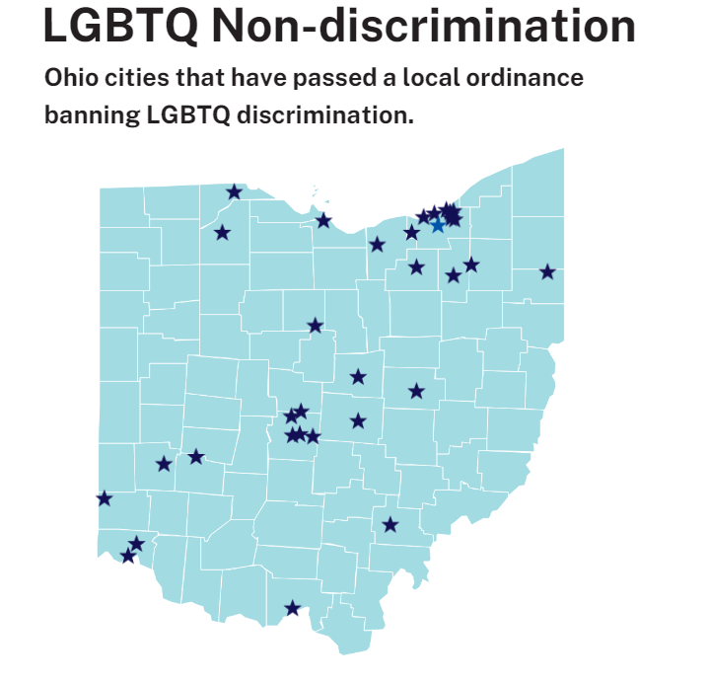
In addition, many Ohio school boards (including Worthington) have policies that specifically prohibit discrimination based on gender identity. {Can we get a list of these?}
So, what does this mean on a day-to-day basis? The law is better developed in some areas than others.
Bathrooms and Locker Rooms: Students are allowed under Title IX to use the bathroom that aligns with their gender identity.
There has been a lot of litigation on this in recent years. The governing case on this is Grimm v. Gloucester Cty. Sch. Bd., 972 F.3d 586 (4th Cir.).
- In Grimm, the 4th Circuit held that equal protection and Title IX protect transgender students from school bathroom policies that prohibit them from affirming their gender.
  - Five years of litigation.
  - The plaintiff is a transgender male. He changed his name to Gavin and expressed his gender identity as male.
  - He was initially allowed to use the men’s restroom. However, as word got out, the school faced significant backlash from parents (not students).
  - As a result, the School Board adopted a policy requiring students to use the restrooms that aligned with their gender assigned at birth and refused to let the plaintiff use the men’s restroom at school.
  - The school also built a single-stall restroom as an alternative (in the nurse’s office initially and later in single-stall units). Echoing what we discussed earlier, the plaintiff explained that this stigmatized him, caused health problems, and led to suicidal thoughts, resulting in his hospitalization.
  - The plaintiff transitioned to male and received a court order stating that he is male, along with an amended birth certificate reflecting his gender as male.
  - The school still refused to amend his school records.
- The decision was appealed to the U.S. Supreme Court, but it declined to hear the case, which means that the 4th Circuit’s decision stands.
- The school board was ordered to pay $1.3 million in attorneys’ fees and costs to the plaintiff-student.

Dodds v. U.S. Dep’t of Ed’n (6th Circuit, pre-Supreme Court denial of cert in Grimms)
- A transgender female student obtained a preliminary injunction ordering the school district to treat her as female and allow her to use the women’s restroom.
- The school district appealed the decision and sought a stay of the injunction while litigation was pending.
- The 6th Circuit declined to stay proceedings, specially reasoning that it would be disruptive to the girl and that allowing her to use the woman’s bathroom had significantly alleviated her stress. The Court also reasoned that granting the stay would allow the school to single the plaintiff out.
- The Court found that the school district was not likely to win on the merits as the 6th Circuit prohibits discrimination based on gender nonconformity.
Locally, in October 2021, the 10th District Court of Appeals in Franklin County affirmed the school district’s plans to include only unisex bathrooms in a new elementary school.
- The school proposed single occupant toilets that were not gender specific as well as a communal bathroom for students for UA’s proposed new elementary school. The Ohio Board of Building Appeals denied a variance for the bathroom design based on a provision of the Ohio Administrative Code that required separate facilities for each sex where plumbing fixtures are required.
- UA appealed and Building Department agreed to the variance and the parties submitted a joint motion for summary judgment allowing the bathroom design.
- A mother of a student then sought to intervene and sought relief from judgment, which the trial court granted. The mother opposed unisex bathrooms.
- The 10th District reversed, finding that the mother lacked a sufficient interest in the dispute to support intervention and it was unreasonable for the trial court to rely on her “personal interest.”
Pronouns, Names, and School Records: Students may be addressed by their preferred name and pronouns on a day-to-day basis. On official school documents such as diplomas and transcripts, the student’s legal name and gender assigned at birth are used unless the student has legally changed their name or gender.
- There is no law requiring schools to call students by their legal name.
- A student’s chosen name and preferred pronoun can be used on unofficial documents.
- Legal name change is generally required to change official record such as school transcript. If you change your name legally, school must honor that change.
- Grimm also involved a refusal to change school records. The 4th Circuit affirmed the lower court and held that the School Board’s refusal to change the plaintiff’s transcripts violated equal protection and Title IX.
  - The plaintiff transitioned to male and received a court order stating that he is male, along with an amended birth certificate reflecting his gender as male.
  - The school still refused to amend his school records.
Can teachers be required to refer to students by chosen names or pronouns? This is an area where the law is developing.
- In Meriwether v. Hartop, 992 F.3d 492 (6th Cir. 2021), the 6th Circuit reversed dismissal of a college professor’s claim that his First Amendment and Due Process rights were violated when he was terminated because he would not use students’ preferred pronouns.
  - So he proposed a compromise: He would keep using pronouns to address most students in class but would refer to Doe using only Doe's last name. Dean Milliken accepted this compromise, apparently believing it followed the university's gender-identity policy.
  - “[T]he academic-freedom exception to Garcetti covers all classroom speech related to matters of public concern, whether that speech is germane to the contents of the lecture or not. The need for the free exchange of ideas in the college classroom is unlike that in other public workplace settings. And a professor's in-class speech to his students is anything but speech by an ordinary government employee.”
  - He was speaking on a matter of public concern. “In short, the use of gender-specific titles and pronouns has produced a passionate political and social debate. All this points to one conclusion: Pronouns can and do convey a powerful message implicating a sensitive topic of public concern.”
  - Held that he plausibly alleged that the pronoun policy burdened his free exercise of religion.

- Rule may be different for high school teachers. See Kluge v. Brownsburg Community Schools Corp. (S.D. Ind. 2021)
  - Teacher resigned/forced to resign for refusing to call student by chosen name.
  - The school had a policy that required staff to refer to students by their chosen name and pronoun if it had been changed in the school’s database. The process allowed name and gender marker changes with a letter from a student’s parent and a healthcare professional.
  - The policy was put in place to support transgender students, recognizing that they face significant challenges in school, including heightened exposure to bullying.
  - The teacher objected based on religious beliefs and suggested that he be allowed to refer to all students by their last names. The school allowed this approach.
  - Students complained about the teacher’s practice of using last names only, stating that they found it insulting and disrespectful, and that the class understood why he was using last names only, which then made the transgender students stand out.
  - Teacher was given the option to abide by the policy, resign, or be terminated. He chose to resign.
  - Kluge asserted 13 claims under Title VII of the Civil Rights Act, the First and 14th Amendments, the Indiana Constitution and other state law provisions.
  - The Court held that he was not coerced to resign, he was not retaliated against, and that the school could not accommodate his religious beliefs without sustaining undue hardship.
  - The school was not required to propose an alternative accommodation or to engage in further discussions regarding a potential accommodation for Kluge.
  - As to Kluge’s religious beliefs, the court found that they objectively conflicted with the name policy, but that there was sufficient evidence of undue hardship.

Student Athletes: Area of Significant Legislation and Court Activity.
There has been a fair amount of news reporting over objections to transgender student athletes, primarily focusing on transgender female athletes. More about parents and communities upset with the concept of transgender female athletes.
Several states have laws allowing transgender students to compete in sports in accordance with their gender identity. Some states require hormone therapy. Other states have no guidelines.
From GLSEN:
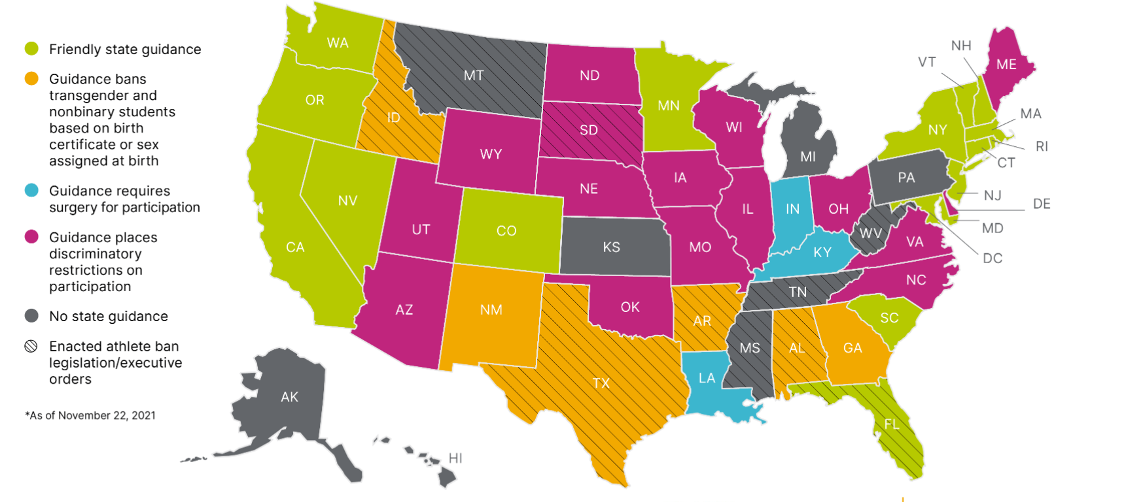
The Ohio High School Athletics Association has adopted a transgender athlete policy:
- Requires transgender female athletes to have completed at least one year of hormone treatment or demonstrate that she does not possess physical or physiological advantages over “genetic females” of the same age group to compete on girls’ team.
- Allows transgender male athletes to compete on boys’ teams if they haven’t begun testosterone treatment for the purpose of transitioning. If the transgender male athlete has begun testosterone treatment, he must demonstrate that “the muscle mass developed as a result of this testosterone treatment does not exceed the muscle mass that is typical of an adolescent genetic boy.” Also requires monitoring of hormone levels.
- There are currently two bills – House Bill 61 and Senate Bill 132 – that would preclude any participation by transgender females on female athletic teams.
Litigation over these issues is ongoing:
- Hecox v. Little (D. Idaho)
  - Challenged an Idaho law that excluded transgender women from participating on women’s sports teams.
  - Included a provision that allowed others to challenge a student’s sex, a process that included an invasive sex verification process.
  - The court issued an injunction in the plaintiffs’ favor.
  - As to equal protection – the concept that all similarly situated people be treated alike – the court reasoned there was a likelihood of success on the merits as the legislation treated transgender women differently without a sufficient basis for doing so.
  - The court reasoned that the legislation was not aimed at promoting equality for women, but was targeted to excluding transgender female athletes.
- Soule – Pending in the Second Circuit (CT)
  - Connecticut had a policy of allowing students to compete in athletics based on their gender identity.
  - This was challenged based on the argument that it put non transgender female athletes at a disadvantage.
  - The Complaint was moot because some of the plaintiffs had graduated and the plaintiffs who were in school could not identify any transgender female athlete against whom they would compete.
  - On appeal to the Second Circuit.
- L.E. v. Lee – Pending in the M.D. Tenn. (filed in Nov. 2021)
  - Transgender male student is challenging a Tennessee law that prevents trans students from participating in sports that match their gender.
  - Similar laws in Idaho and West Virginia were blocked.

Privacy – What must be disclosed to parents?
- The Family Education Rights Privacy Act, 20 U.S.C. § 1232g; 34 CFR Part 99, applies to all aspects of a student’s identity, including their gender identity and transgender status. Legal name and gender assigned at birth are confidential information that schools should not disclose without the student’s consent.
- Only school employees with a “legitimate educational interest,” the student, or their parent or guardian, may have access to a student’s records, including the records of transgender and nonbinary students.
- Generally, a student also has a right to privacy regarding transgender status, sexual orientation, and gender identity. Not an absolute right.
- Nguon v. Wolf, 517 F.Supp.2d 1177, 1193 (C.D.Cal.2007): students have a right to have schools not disclose their sexual orientation without their consent.
  - The plaintiff was “out” at school. However, her home life was insular and she had not come out to her parents. Thus, while she expressed her sexual orientation at school, the plaintiff still had a reasonable expectation of privacy as to her parents.
- This is a conditional right to privacy. Thus, the Court found that because the disclosure was factual and in the context of explaining the reason for discipline, the student’s privacy rights were not violated. "The Court recognized student's reasonable expectation of privacy concerning her sexual orientation but found no violation in disclosure to family in disciplinary context." This does, however, prevent gratuitous outing of students.
- A student may use a different name or to disclose their gender identity to staff, educators, or other students. That does not authorize you to disclose this information.
- Best practice is to understand the students’ communication preferences in school and to parents/at home.
- Doe v. Madison Metropolitan Sch. Dist. (Wisconsin)
  - Parents sued school district claiming that it violated their constitutional right to direct the upbringing of their children by adopting a policy that instructed educators not to disclose a student’s gender identity to the student’s parents unless the student consented to the disclosure.
  - Instructed teachers to refer to students by their affirmed names and pronouns and to allow students this right, regardless of parental permission.
  - The trial court enjoined the school district from enforcing the policy “in any manner that allows or requires District staff to conceal information or to answer untruthfully in response to any question that parents ask about their child at school, including information about the name and pronouns being used to address their child at school.”
  - The Court clarified that this does not create an affirmative obligation to disclose information if not existing at law nor does it require staff to disclose information they are prohibited from disclosing to parents under federal or state law.

College Essay from Winnie Plante who has been accepted at 5 colleges such as Ohio University and Purdue.

Being transgender is the least interesting thing about me. I’m a high school student who collects houseplants and loves to cook, but I also happen to be transgender. While my gender identity does not define me, it is the piece of me I am most proud of, the piece that will never leave the load-bearing pillar of who I am.

Growing up I always had a flair for the dramatic and an affinity for barbies, dress up, and princesses. This alongside my feminine voice and preference of making flower crowns over playing sports caused me to feel different from the other boys I met. Whispers of things like “half-boy half-girl” and “she/he” from peers caused me to feel uncertain and insecure in who I was. My body didn’t match my soul; everyone around me, including myself, knew that fundamentally, I was against the “norm.” At the time, I couldn’t find the words or even form the thoughts to express the complex nuances of being transgender. I didn’t even understand what transgender meant.

Despite my lack of understanding as to why, I knew there was something wrong with my body. The dizzying emotions and thoughts in my mind were undefined until I went dress shopping alongside my mother and sister. In preparation for my mom’s wedding, we had to complete the chore of finding me a suit. Even though the suits I tried on fit my body, they did not fit my soul. At that moment it hit me. I didn’t want to wear a suit. I wanted to wear a dress. I finally realized what was so wrong with my body: I was in the wrong one. Suddenly, images of my future life flooded my mind; I envisioned myself as a beautiful bride, a mother, a woman.
From that day forward, an insecure little boy began transforming into a confident young woman. However, my journey was not always easy. In my freshman year of high school, I was cornered by a loose acquaintance. Approaching me with insincerity masked by curiosity, he hurled invasive questions and colorful slurs such as, “How do you even use the bathroom?” and, “Are you a real girl?” Refusing to dignify his behavior with emotional retaliation, I swallowed my rage and chose love over hate. Seeing this as a chance to educate, I replaced the reciprocal venom I thought I wanted to fire back with stories of my experiences and answers to his less invasive questions.

Throughout battles with ignorance and sadness, I persevered. When negative emotions and disapproving peers attempted to push me back, I stood tall and proud and carried on. This pride is the driving force behind my avid reach towards acceptance for myself and everyone else in the LGBTQIA+ community. When gender-confused, transgender, and even cisgender peers approach me with questions, I am delighted to help and provide answers. By answering these questions I can educate and provide a guiding light in a sea of misinformation. Knowledge is the best and only weapon to combat intolerance, and because of my unique gender identity, I get to have a hand in creating a safer, more accepting world. I have learned that when rumors swirl and assumptions attack, only the proud can calm the storm.

Now I can look at my journey and see how far I have come, not how far I have to go. Roadblocks of ignorance and potholes of insecurity once hindered my path, but my pride now bulldozes and fills them. Looking back, I don’t even recognize the insecure little boy I once was. While being transgender may be the least interesting thing about me, my journey is not.

