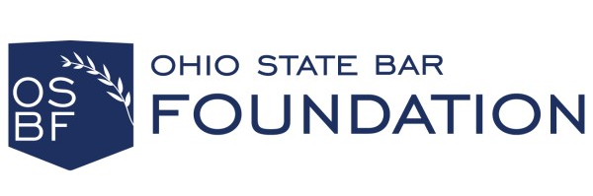
GENERAL GRANT CYCLE APPLICATIONS
At the OSBF, we believe that philanthropy can be more effective and impactful when it is rooted in trust and transparency. For that reason, we are reimagining the relationship between the Foundation and nonprofits. We are intentionally taking a transformative approach to emphasize mutual trust and collaboration with all our partners.
Each year, it is our general grant cycle which provides introductions to amazing organizations across the state who are working to create a more just and equitable legal system for all Ohioans. Therefore, regarding the general grant cycles, we’d like to offer the following considerations, which are intended to assist organizations in submitting a strong grant application:
- Mission Alignment is imperative. All applications must align with the Foundation’s mission.
Additional factors, which are not ranked in order of importance, include:
- Single Project – while the proposed project may be part of an ongoing program or endeavor, the scope of the work should be clearly defined. Projects that demonstrate innovation to address unmet needs are likely to be favored.
- Timeframe – the Foundation generally awards funding on an annual basis. It is possible that funding could be awarded beyond a 12-month timeframe, but that would be the exception rather than the rule.
- Need/ Planned Impact – the applicant should be working to address an existing need. Projects that duplicate similar services or programs that already exist are likely to be disfavored unless they are intended to coordinate with existing services.
- Organizational Capacity & Readiness – the applicant should demonstrate relevant qualifications, experience, and capacity to achieve the intended outcomes.
- Other Sources of Funding – applicants are encouraged to identify other secured and/or potential sources of funding to make the project viable.
- Budget – proposed activities and intended outcomes should be aligned while demonstrating efficient resource allocation and financial feasibility.
- Geographic Focus – the Foundation strives to fund projects in Ohio with a focus placed on geographic diversity across the entire state.
- Equity & Inclusion – applicants are encouraged to articulate how they plan to address the needs of underserved, vulnerable, and/or marginalized populations.
- Partnerships – the Foundation encourages collaboration and the sharing of knowledge and best practices.
- Evaluation of Impact – applicants should articulate methods for evaluating and assessing both qualitative and quantitative outcomes. At the conclusion of the grant period, applicants will be asked to complete the Foundation’s evaluation of impact.
- Sustainability and Replicability – applicants are encouraged to consider plans for sustainability of the project beyond the grant period. Additionally, projects that could be replicated across the state are likely to be favored.
As a reminder, the Ohio State Bar Foundation is a public charity. Therefore, we do not fund political campaigns, lobbying, or any other activity that is not consistent with our status as a nonpartisan, 501(c)(3) organization.

